Appendix 1.3: Task 3 Social Media (YouTube & Instagram)
Appendix 1.3: Text - YouTube Banner (Desktop & Mobile)
Text in blue must be used and, in the order, it appears within each page.
[ Heading ]
HealthBeats® Offline Mode is now LIVE!

[ Body Text ]
Regardless of internet access, you can continue to enjoy:
1. Uninterrupted vitals measurement
2. Continue to receive alerts
3. Automatic synchronisation of data
Appendix 1.3: Text - Instagram Post
Text in blue must be used and, in the order, it appears within each page.
[ Heading ]
HealthBeats® Offline Mode is now LIVE!

[ Body Text ]
No internet does not mean you stop managing your health. HealthBeats' users can now continue to manage their health proactively even without internet access.
[ Feature Text ]
1. Uninterrupted vitals measurement
2. Continue to receive alerts
3. Automatic synchronisation of data
Appendix 1.3: Images - 01. YouTube & Instagram Folder
[ TOTAL 25 images name and Pictures ]
01 Mask Image Clincian.jpg   | 02 Mask Image Patient.jpg  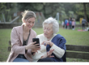 | 03 Mask Image Monitoring.jpg   | 04 Offline Mode Icon.svg  
05 Offline Measuring.png  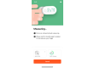 | 06 Offline Mode Care Tasks Overview.png  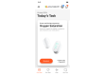 | 07 Offline Clinician Data.png  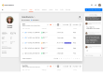 | 08 Lifestyle Park.jpg  
09 Lifestyle Forest.jpg  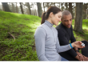 | 10 Joyful Lady.jpg   | 11 Male checking phone.jpg   | 12 couple in kitchen.jpg  
13 Sharing Discussion.jpg   | 14 Communication Call.jpg   | 15 Take reading outdoor.jpg  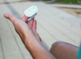 | 16 senior woman doctor.jpg
17 remote communication with patient.jpg   | 18 Patient handshake with doctor.jpg   | 19 Family Gathering.jpg   | 20 review results.jpg  
21-daily-vitals-chill.jpg  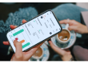 | 22 Taking Flight.jpg   | 23 Clinician checking ipad.png   | 24 Offline Notification Alerts.png  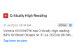
25 Elderly in park.jpg


Appendix 1.3: Images - 02a. Mockup YouTube Folder
[ TOTAL 2 mockup images name and Pictures ]
YouTube Banner Desktop Mockup Template.png
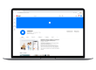
YouTube Banner Mobile Mockup Template.png
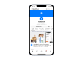
Appendix 1.3: Images - 02b. Mockup Instagram Folder
[ ONLY 1 mockup images name and Pictures ]
Instagram Post Desktop Mockup Template.png
